***Plan of Approach***

**Tim Verhees**

*06-09-2022   
V1.0*

# **Versions**

|  |  |  |
| --- | --- | --- |
| **Date** | **Version** | **Description** |
| **02-09-2022** | 0.1 | Initial version |
| **06-09-2022** | 0.2 | Second version, still a work in progress |
| **06-09-2022** | 1.0 | First finished version |

# **Distribution list**

|  |  |  |  |
| --- | --- | --- | --- |
| **Date** | **Version** | **Name** | **Function** |
| **06-09-2022** | 0.2 | Tim Verhees | Project Handler |
|  |  | Jacco Snoeren | Technical Teacher |
| **23-09-2022** | 1.0 | Tim Verhees | Project Handler |
|  |  | Maja Pesic | Technical teacher |

**Table of contents**

**Versions** 2

**Distribution list** 2

**1.** **Introduction** 4

**2.** **Objective** 4

**3.** **Assignment description** 4

**4.** **Conditions and starting points** 4

**5.** **Critical Success factors** 5

**6.** **Products to be delivered** 5

**7.** **Approach** 6

**8.** **Planning** 6

**9.** **Project organisation** 7

**10.** **Risk analysis** 7

**11.** **Communication** 8

# **Introduction**

Yu-Gi-Oh is a trading card game made by Konami following the popular kids cartoon Yu-Gi-Oh. It was released in 1999 and was an instant hit. In the years to follow Konami would release set after set of cards containing new monsters, spells, traps, etc. With such attention the game was pushed to grow and grow. Looking back today, the game has evolved significantly, and so did the people playing it. More and more players became more and more serious about the game, creating a competitive scene for the game. This required that Konami would address some of the cards that were deemed an issue.

This was the birth of the “Ban List”. A list consisting of all the cards not allowed to be used in regular and competitive play. This list includes cards that can only be used twice or once, instead of the regular three times and even cards that are outright forbidden. This list is changed every once in a while, cards getting added to it, removed from it. However one thing remains relatively absolute. You have to abide by this list. Some players though, feel that the list is not accurate enough in accordance with the current state of the competitive scene.

# **Objective**

With this project I aim to create a simple program that would allow users to construct their own “Ban List”. In this program regular users can create their own ban lists and admins will be able to add new sets to the list of available cards as the game evolves and if possible, add images to the cards.

# **Assignment description**

The assignment is to create an application that applies several learning outcomes presented by Fontys. It has to include several elements we learn throughout semester 3, an example of which is the usage of a RESTful API and dependency Injection. The assignment is to be carried out in sprints of 3 weeks each.

# **Conditions and starting points**

1. Conditions
2. The deadline for the project is week 18 of the semester;
3. The project is to be delivered on Canvas;
4. The products delivered will only be realised by the student;[1]
5. The project must abide by the learning outcomes and show progress in those areas.
6. Starting points
7. The student follows the planning of the semester and the project without defects;
8. Both the coach and the teachers will, at several points throughout the semester, be available for questions, feedback and general advice regarding the project;

# **Critical Success factors**

Here are some of the factors that could be seen as critical for a successful completion of the project:

1. The student actively seeks help and feedback regarding points of concern and/or difficulty with the project.
2. Everything needs to be documented according to both the school’s guidelines and in a way that the choices made throughout the project are documented and backed up.
3. There needs to be a concise planning on what is going to be performed when, for example what is going to be realised during the first, second and third sprint.
4. The coaches and teacher need to be available for feedback and help.
5. At the end of the project there needs to be back-end and front-end application that fills the most important requirements.

# **Products to be delivered**

These are the products that are to be delivered at the end of the deadline. Not all products share the same deadline.

|  |  |
| --- | --- |
| Product | Delivered to |
| Plan of Approach | Jacco & Maja & Ali |
| Product Backlog | Jacco & Maja & Ali |
| Prioritization | Jacco & Maja & Ali |
| Estimation | Jacco & Maja & Ali |
| Acceptance | Jacco & Maja & Ali |
| Proof of Concept | Jacco & Maja & Ali |

# **Approach**

As per the requirements of this semester, I will be working in an Agile method. I will be utilizing sprints to iterate my front-end and back-end applications. There are some documents, like this one for instance, that will be universally applicable, and so will only be made once. However others, like requirements and prioritization, will be made in accordance with the current sprints goal.

Below is a visual representation of how these sprints will look and function.

Source: <https://blogs.gladwellacademy.com/nl/waarom-de-sprint-planning-onmisbaar-is>

I will also keep a planning on the website called Trello. Here I can keep track of what needs to be done, what is currently being worked on and what is finished.

# **Planning**

As mentioned before my planning will be made in a third party website called Trello, an example of how that planning will look like is this. 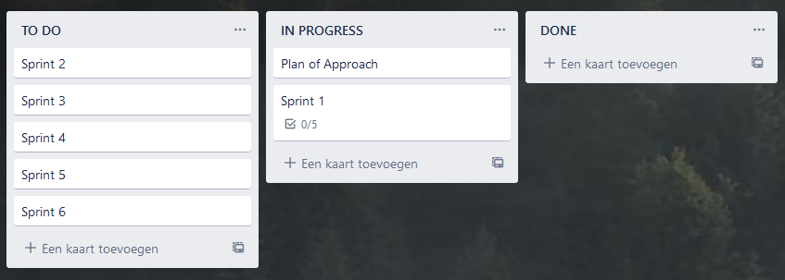

# **Project organisation**

Within this project there are a few roles that come into play.

|  |  |  |
| --- | --- | --- |
| Role | Name | Responsibilities |
| **Project Handler** | Tim Verhees | This is the person who makes the project. They are responsible for documentation, realisation and argumentation for the project. |
| **Technical Teachers** | Jacco Snoeren, Maja Pesic | These are the technical teachers that will teach some of the concepts applied in the applications. They will also be available to help the project handler if they have questions and provide feedback on the progress of the project. |
| **Semester Coach** | Ali Odaci | The semester coach helps the project handler along the path of the project, giving them pointers in regards to any difficulties during the project. They will also provide general information in regards to future semesters. |

# **Risk analysis**

As with any project there are a couple of risks that come along with it, here are a few.

1. Discontinuation of the external API that is in use.
2. Unavailability of technical teachers for questions.
3. Loss of access to school related programs, example Teams, mail.
4. Slowdown due to unfamiliarity with programs.
5. Not being able to realise everything in a sprint and having to go back.
6. Not finishing the project on time.
7. Trouble of balancing the individual project with the group project.

|  |  |  |  |
| --- | --- | --- | --- |
| **Impact \ Chance** | **Low** | **Mid** | **High** |
| **Large** | 1,2,6,7 |  |  |
| **Medium** | 3 | 5,9 | 4 |
| **Small** |  |  |  |

And of course, the proposed solutions to these risks.

|  |  |
| --- | --- |
| Nr. | **Solution** |
| 1 | One of the possible solutions is making the application not depend on the external API by getting the data from it and storing it locally in a database or switching to just not using it at all. This would require entering a lot of the data by hand. |
| 2 | In this case I will have to search for other teachers that are not tied to the class. |
| 3 | A solution to this would be working on something else whilst working on getting access to these programs back. |
| 4 | This is a hard one, seeing as it has been a while since I have coded, combined with the sudden usage of Java to create the program. The solution for this would be to keep up with the classes and ask questions when they arise. |
| 5 | By working as planned in the allotted time slots this should not become an issue, if it does however, spending more time on the individual project in comparison to the group one should help. |
| 6 | The way to combat this problem is to always work on time and meet the deadlines of the sprint, also asking for help when needed will prevent this from happening. |
| 7 | Having a concise planning of when to work on the individual project and when to work on the group project. For instance, three days on individual and two days on group project. |

# **Communication**

Communication during this project will mainly take place in person. Small questions, however, could be asked through e-mail or through Teams. This is assuming that the school stays open with the current covid climate.

Documents relevant to the project are to be sent in through Canvas, and feedback (including the processing of it) through a side part of Canvas called FeedPulse.

In this feedback the points of interest discussed are to be documented on FeedPulse.

Some examples of this would include:

* Subject;
* Decisions;
* What’s going wrong;
* What’s going right;
* What document was shown;
* The feedback on said document;
* Any tips given by the teacher.

1. It is however possible for the student to ask questions to their coach and technical teachers